Working 1

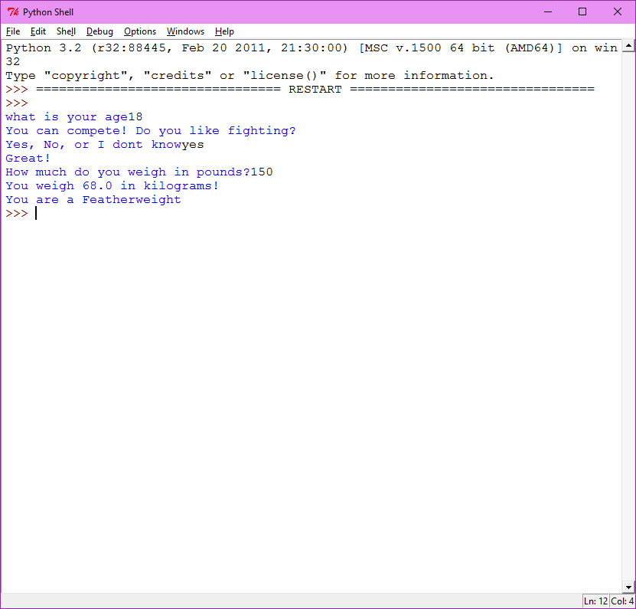

Working 2

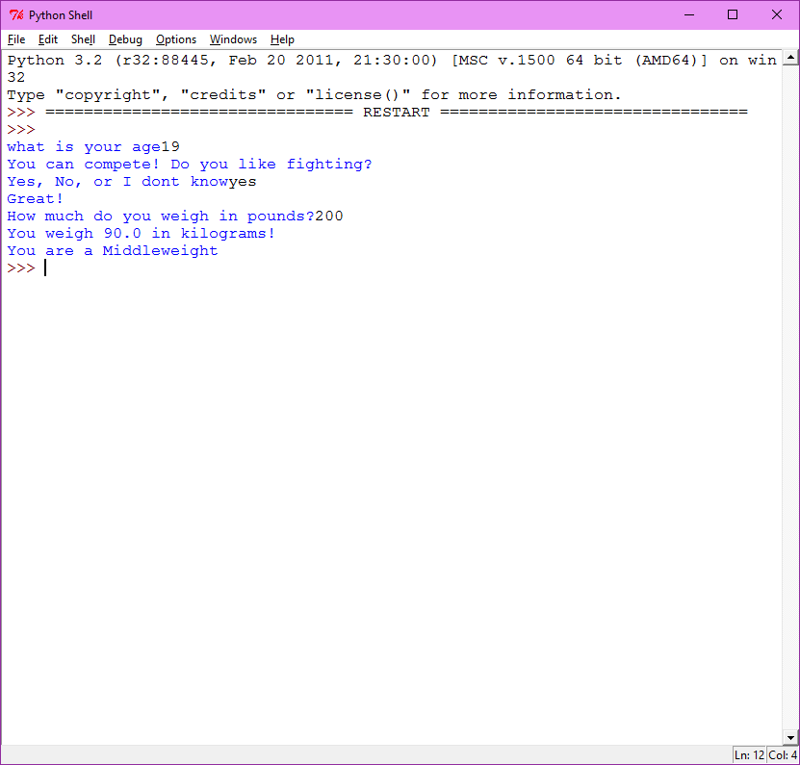

Bad input 1

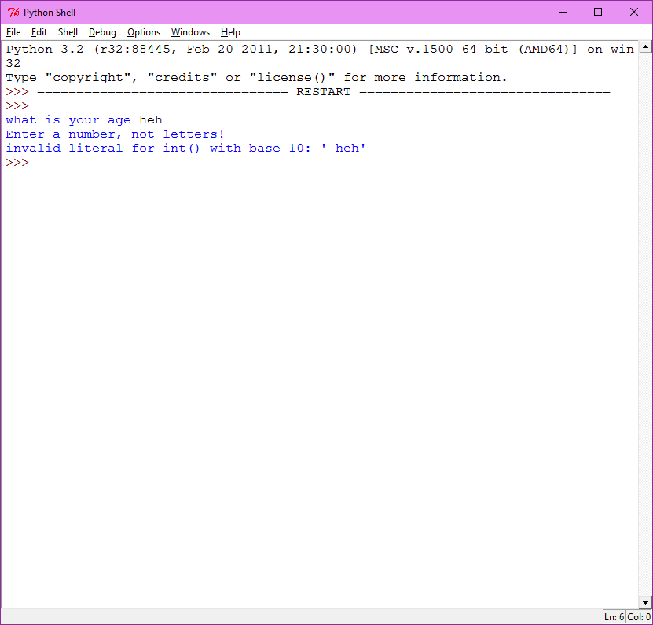

My Program converts pounds into kilograms with a constant and tells you your weight class.

#Robert C. Plata III Lab 3 9/11/2015

#Professor Sally Kyvernitis

#REQUIREMENTS ~done~

#A_CONSTANT ~done~

#2 USER NUMBERIC INPUTS ~done~

#PERFORM SOME CALCULATION WITH THE CONSTANT AND 2 USER INPUTS ~done~

#TRY BLOCK CONTAINING ALL ~done~

#EXCEPT BLOCK ~done~

#USER SHOULD ENTER A STRING WITH 3 OR MORE CHOICES. ~done~

#IF/ELIF STRUCTURE ~done~

#include concatination if you can ~done~

CONVERSION_CONSTANT=2.2046226218

try: #Trying code

age=input("what is your age")# user inputs age

age=int(age)#age is integer

yearsUntil = 18 - age#years left until 18

if age >= 18:#if over 18, continue program

print ("You can compete! Do you like fighting?")#indentation for the program if user over 18

answer=input("Yes, No, or I dont know")#question

answer=answer.upper() #make all upper

answer=answer.strip() #make all spaces outside disappear

if answer == "YES": #the answer is yes, indent and allow to program to go on

print ("Great!") #Great print

pounds=input("How much do you weigh in pounds?")#user pounds input

pounds=float(pounds)#pounds is floating number

kg = pounds * (1 / CONVERSION_CONSTANT)#math for kilograms with constant

kg = kg * 100#kg times 100

kg = kg // 100#kg integer division answer is now not a long decimal

if pounds <= 2:#pounds under 2 is not a full kg

print("That wont be a full kilogram yet!")

elif kg < 57:

print ("You weigh "+ str(kg) +" in kilograms!")#these are all outcomes for the kilogram number

elif kg < 60:

print ("You weigh "+ str(kg) +" in kilograms!")

print ("You are a Flyweight ")

elif kg < 65:

print ("You weigh "+ str(kg) +" in kilograms!")

print ("and you are a Bantamweight ")

elif kg < 69:

print ("You weigh "+ str(kg) +" in kilograms!")

print ("You are a Featherweight ")

elif kg < 76:

print ("You weigh "+ str(kg) +" in kilograms!")

print ("and you are a Lightweight")

elif kg < 83:

print ("You weigh "+ str(kg) +" in kilograms!")

print ("and you are a Welterweight ")

elif kg < 92:

print ("You weigh "+ str(kg) +" in kilograms!")

print ("You are a Middleweight")

elif kg < 119:

print ("You weigh "+ str(kg) +" in kilograms!")

print ("You are a Light Heavyweight ")

elif kg >= 120:

print ("You weigh "+ str(kg) +" in kilograms!")

print ("You are a Heavyweight")

elif answer == "NO":

print ("oh that's too bad.")#doesnt continue the program, indent aligns with multiple choice

elif answer == "I DONT KNOW":#doesnt continue the program, indent aligns with multiple choice

print ("Learn more about it")

else:

print("no option for that")#if user doesnt enter an option listed

else:

print("Darn you aren't over 18! You have " + str(yearsUntil) +" years until you can compete.")#user enters a number lower than 18, and this aligns with first question

except Exception as error:

print ("Enter a number, not letters!")#user enters a string instead of number

print (error)